GEORGE BACCHUS AFFIDAVITS
- Affidavit #1
- Affidavit #2
The People's National Congress Reform condemns the political execution of George Bacchus in his bed in the wee hours of the morning of Thursday June 24, 2004. This execution confirms George Bacchus’ contention that the bullets that Shafeek Bacchus received were indeed intended for him.
Mr. Bacchus, as the public knows, was one of the key witnesses to the operations of state sponsored death squads. He confirmed, for instance, in a sworn affidavit, dated June 11th, 2004, that he was present when Ronald Gajraj issued an order to the death squad to kill Othneil Embarack (aka Agouti) and five other young men in Robb and Light Streets, Bourda on the night of Diwali 2003.
Over the past months, Mr. Bacchus has provided the public/nation with information implicating several high-level government officials in the operations of death squads. In that time Mr. Bacchus received serious threats to his life and the lives of his family and had publicly stated that he had become a target by agents of the State.
Two weeks ago, Mr. Bacchus revealed in a video recording and in a sworn affidavit that he was terrorized by agents of the State and Ronald Gajraj into making a statement exonerating Gajraj and that he had complied in order, in his own words, “to live a little longer”.
The People's National Congress Reform therefore has no doubt that the execution of Bacchus was a deliberate attempt to silence him and to protect those who have been implicated in the death squad operations. In our last press statement, the PNCR had made public its concerns over attempts by the state to tamper with witnesses since the announcement of the Presidential Commission of Inquiry. Mr. Bacchus’ execution clearly demonstrates the extent to which those implicated are willing to go to protect themselves. This latest political killing is clearly an attempt by the PPP/C government to cover its tracks and to scare away other potential witnesses.
The Guyanese public can now judge for themselves the true nature of the PPP/C regime. We hold Jagdeo and his entire government responsible for the political execution of George Bacchus. The shocked citizens of Guyana must now respond appropriately and decisively to this further act of lawlessness and wantonness committed by this government.
The Leader of the People's National Congress Reform, Mr. Robert Corbin, has submitted to the Commissioner of Police two affidavits sworn to by George Bacchus and a video recording of an interview he gave, and has called on the Commissioner to immediately launch a murder and conspiracy to murder investigation.
People's National Congress Reform
Congress Place, Sophia
Georgetown
June 24, 2004

AFFIDAVIT #1
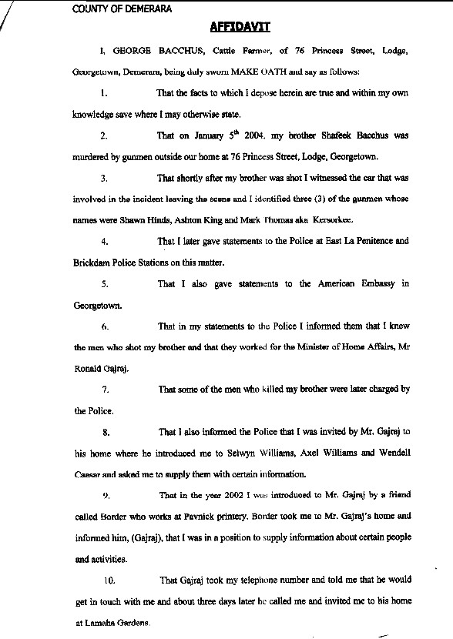
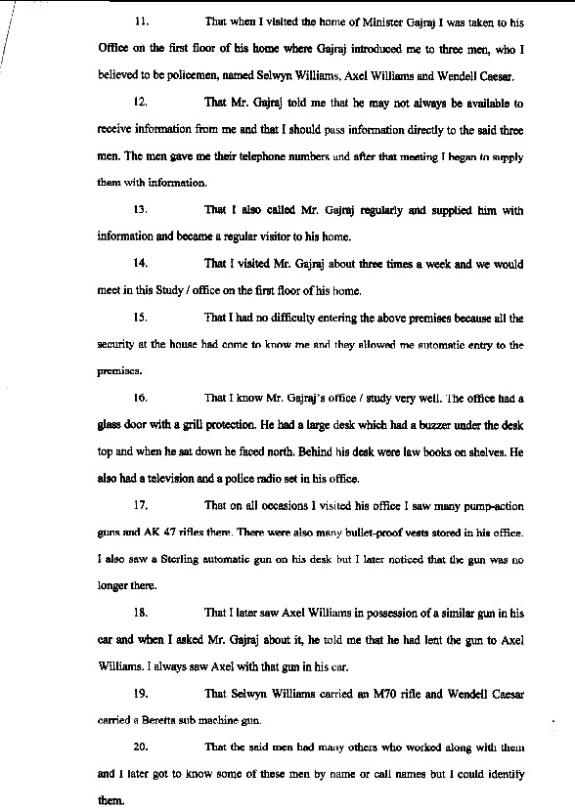
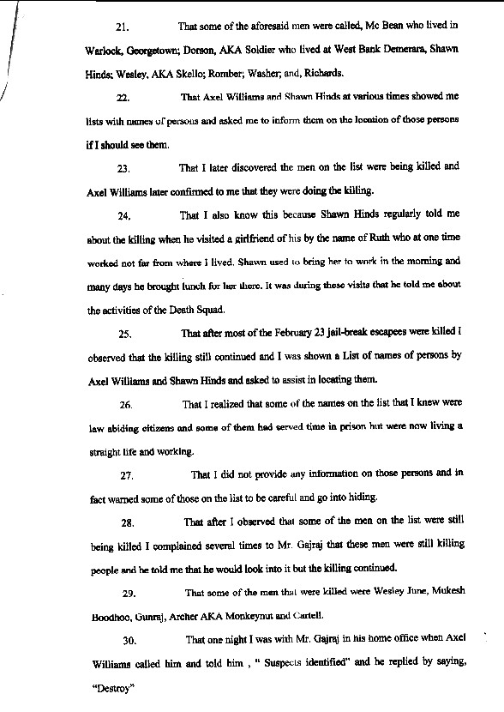
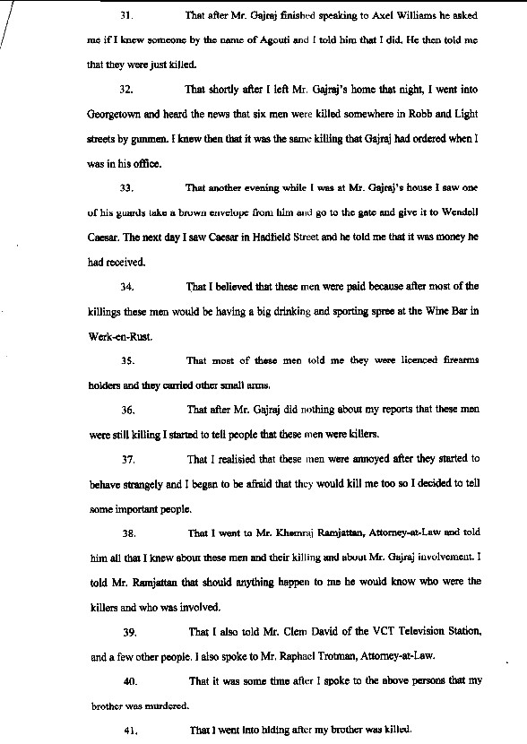

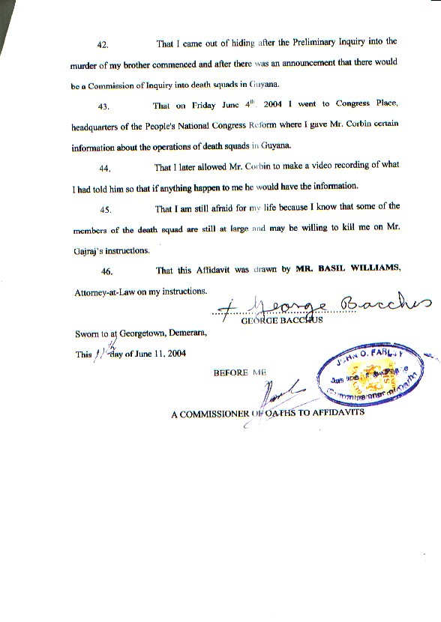
Top
AFFIDAVIT #2
